Batch: C3 Roll No.: 16010123217

Experiment No. 5

Grade: AA / AB / BB / BC / CC / CD /DD

Signature of the Staff In-charge with date

Title: Study, Implementation, and Analysis of Job Sequencing with Deadlines.

Objective: To learn the Greedy strategy of solving the problems for different types of problems
CO to be achieved:
CO 2 | Describe various algorithm design strategies to solve different problems and analyse Complexity.

Books/ Journals/ Websites referred:
- Ellis horowitz, Sarataj Sahni, S.Rajsekaran,” Fundamentals of computer algorithm”, University Press
- T.H.Cormen ,C.E.Leiserson,R.L.Rivest and C.Stein,” Introduction to algortihtms”,2nd Edition ,MIT press/McGraw Hill,2001
- http://lcm.csa.iisc.ernet.in/dsa/node184.htm
- http://students.ceid.upatras.gr/~papagel/project/kruskal.htm
- http://www.personal.kent.edu/~rmuhamma/Algorithms/MyAlgorithms/GraphAlgor/kruskalAlgor.html
- http://lcm.csa.iisc.ernet.in/dsa/node183.html
- http://students.ceid.upatras.gr/~papagel/project/prim.htm
- http://www.cse.ust.hk/~dekai/271/notes/L07/L07.pdf

Pre Lab/ Prior Concepts:
Data structures, Concepts of algorithm analysis

Historical Profile:The Job Sequencing with Deadlines problem is a classic optimization problem where the goal is to schedule jobs to maximize profit, ensuring each job is completed before its deadline. The algorithm follows a greedy approach.The Job Sequencing with Deadlines Problem is a foundational optimization problem in scheduling theory and computer science. Its historical development is closely tied to advancements in algorithm design, combinatorial optimization, and practical applications in operations research and industrial processes.

Origins and Early Development
Scheduling Problems in Industry (Mid-20th Century):The problem emerged during the industrial revolution and later in the mid-20th century with the rise of operational research.Scheduling tasks to maximize efficiency, minimize delays, or maximize profits became critical for industries like manufacturing and logistics.
Development of Mathematical Formulation:Researchers began formalizing scheduling problems, including constraints like deadlines and profit maximization, laying the groundwork for job sequencing problems.The focus shifted from heuristic or ad-hoc methods to formal algorithmic solutions.

New Concepts to be learned:
Application of algorithmic design strategy to any problem, Greedy method of problem solving Vs other methods of problem solving, optimality of the solution, knapsack problem and their applications

Algorithm:
Input: A set of n jobs, where each job i has:
    - pi​: Profit if the job is completed.
    - di​: Deadline (maximum time slot by which it should be completed).
Output: A schedule of jobs such that:
- Each job is completed within its deadline.
- The profit is maximized.

Step 1: Sort Jobs by Profit. Sort all jobs in descending order of their profit pi​. Jobs with higher profits are prioritized.

Step 2: Allocate Time Slots
- Iterate through the sorted jobs.
- For each job: Find the latest available time slot t≤di​ (the deadline of the job).If a time slot is available, schedule the job in that slot and update the slot as occupied.

Step 3: Output the Job Schedule.(Return the scheduled jobs and the total profit.)

Example:
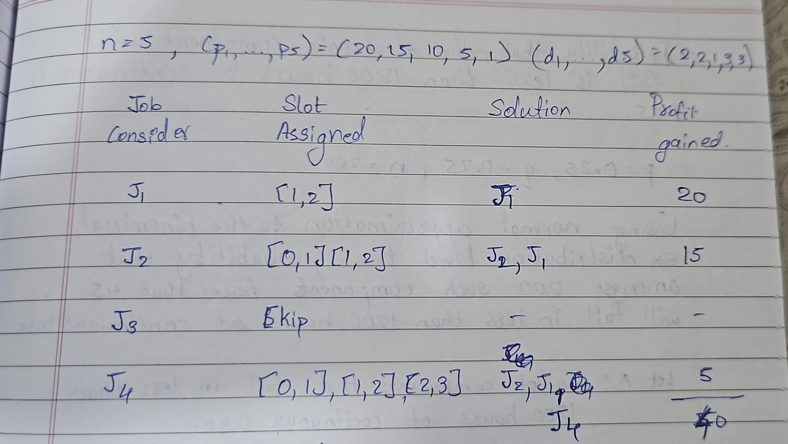

Code:

#include <bits/stdc++.h>
using namespace std;

#define int long long
#define endl "\n"

const int MOD = 1e9 + 7;
const int INF = LLONG_MAX >> 1;

bool compare(pair<int, int> &a, pair<int, int> &b){
return a.first > b.first;
}

void job_seq(vector<pair<int, int>> &jobs, int n) {
sort(jobs.begin(), jobs.end(), compare);

int slots = 0;
for(int i = 0; i<n; i++){
slots = max(slots, jobs[i].second);
}

vector<int> seq(slots, -1);

int profit = 0, count = 0;

for(int i = 0; i < n; i++){
int job_profit = jobs[i].first;
int job_deadline = jobs[i].second;

for(int j = job_deadline - 1; j >= 0; j--){
if(seq[j] == -1){
seq[j] = i + 1;
profit += job_profit;
count++;
break;
}
}
}

cout << "The sequence of jobs is: ";
for(int i = 0; i < slots; i++){
if(seq[i] != -1){
cout<<seq[i]<< " ";
}
}
cout<<endl;
cout<<"Maximum profit: "<<profit<<endl;
}

signed main() {
cout<<"Enter the number of jobs: ";
int n; cin>>n;

vector<pair<int, int>> jobs(n);
cout << "Enter the profit and deadline of each job: ";
for(int i = 0; i < n; i++){
cin>>jobs[i].first>>jobs[i].second;
}

job_seq(jobs, n);

return 0;
}

Output:

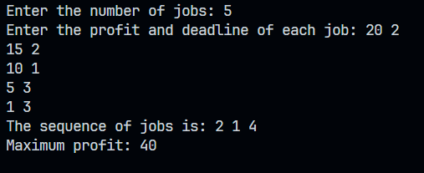
Analysis of algorithm:

Time Complexity:

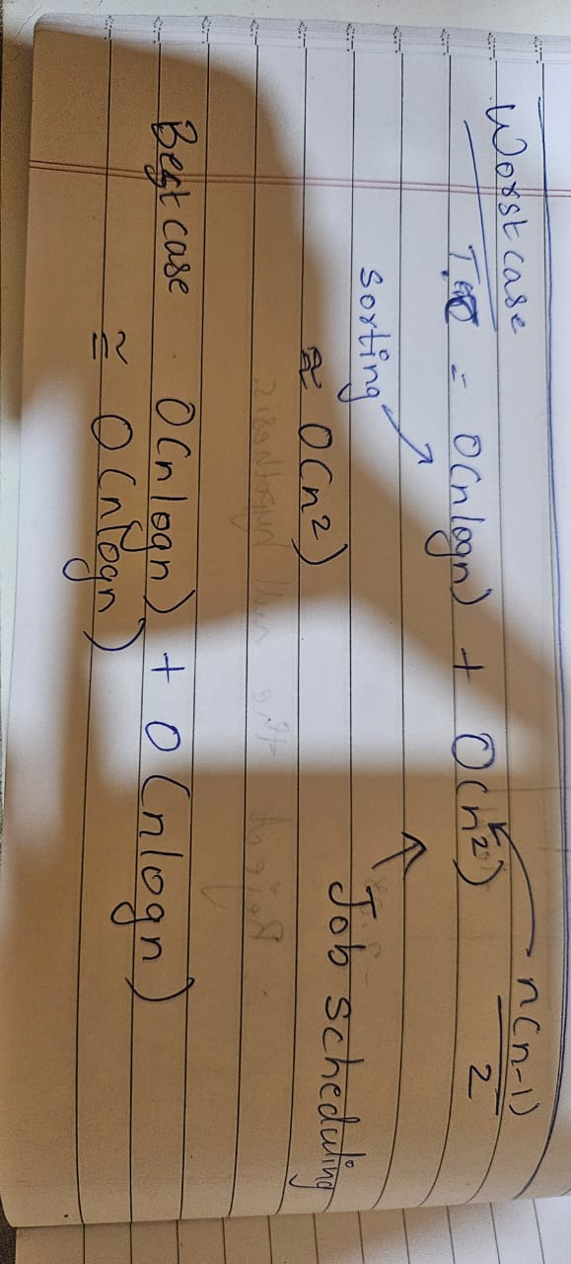

Space Complexity:
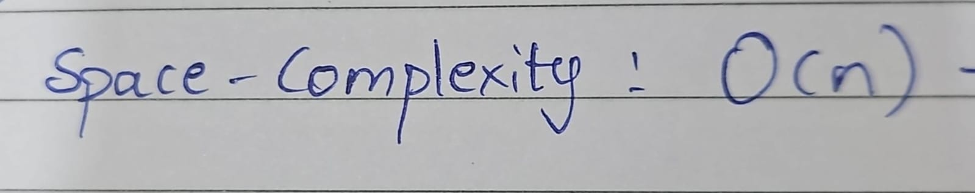

Conclusion:
From this experiment we learnt about the famous job scheduling algorithm with time complexity of O(n²) and space complexity of O(n)

